
Shri Shamrao Patil (Yadravkar) Educational & Charitable Trust’s
Sharad Institute of Technology College of Engineering, Yadrav (Ichalkaranji)
(An Autonomous Institute)
Department of Artificial Intelligence & Data Science
A
Mini Project Synopsis
On
“EXPLORE KOLHAPUR”
Submitted by
Name of Student | Roll. No. | PRN No.
Mr. Kagade Prajwal Arjun | T39 | 2210101019
Mr. Kamble Prashil Prakash | T40 | 2210101020
Mr. Khade Abhishek Bharat | T41 | 2210101021
Mr. Shinde Chetan Sudhir | T64 | 2220101052

Under the Guidance Of
Mrs. P
2024-25

Guide HOD Principal
(Mrs. ) (Dr.A.J. Chinchawade) (Mr. S.A. Khot)

Abstract
There are so many travelling websites but, in that website, only some information about destination is provided, for example: they provide destination photos, some information related to that destination, history of that place etc. It is not efficient for the traveler or the user because if the user wants to find nearby places to visit, nearby residentials, nearby restaurant’s, map of that place etc. they should need to search separately, so we think that if we provide these all kind of information in a single website it could be more efficient for user to find and plan the proper trek.
In this we should provide clean design that is responsive and easy to navigate. We should provide a dynamic and real content in the website. We will use computer languages like HTML, CSS, JavaScript, Bootstrap5, and give backend using python or using Django if needed. Using JavaScript, we should provide search bar to browse through thousands of destinations and activities, from popular tourist attractions to hidden gems. You should get personalized recommendations based on your preferences, budget, and travel style. You should get information about actual price for booking flights, hotel, car rentals etc. We also try to make a community of traveller’s tips, reviews, and photos.
Our idea is to create a user-friendly website and easily accessible for user at any place. The website should be operated on any device like PC, Laptops, Tablets and also on Mobile phones.

Introduction
Rationally the peoples don’t know the proper information about the destination, how to visit that place, Is there any facilities available or which places are surrounded by the destination they must know but they don’t get the proper source to get information. To overcome these problems, we have created the website “EXPLORE KOLHAPUR”. By using our website, they will get proper guide and proper information about the destination or places. In the dynamic landscape of many travelling websites, our mini-project seeks to address a pressing question: user/traveller not getting a proper information and guide for travelling at one place. This mini-project aims to provide a proper and reliable information, for finding best way for visiting destination, best and low-cost hotels and residentials near destination.
Our mini-project holds significance in providing a dynamic and real content about any place in Maharashtra. The user will get personalized recommendations based on user preferences, budget, and travel style. User also get current information about place or destination. Our website will provide user information about the nearby hotels, restaurants, and residentials. With this information website should provide link of website, their contact number, rent of room as per hour and location of that restaurant. User can also get information about travelling medium like flights, cars, boats etc. with this user will get the cost for the flight tickets and boat rents this could help the user for planning the trip in budget. In our website the information of place is provided with google map. This googles map could help the user for finding the shortest route or best route.
For example, if user wants to visit any fort, then he /she could see the pictures of relative place. After that user will get the detailed information about history, facts, and culture of that place. Then user could see the nearby place to visit, these places will also provided with history, facts, and culture. This website will help the people for the proper trip planning. The user interface is very easy to operate. Any educated as well as uneducated user can operate this website very friendly. For finding the place user should need to search or browse the place in the provided search bar. User can also give their feedback, review and changes need in the information.
In this website we have provided the all-in-one information. This website is responsive so some users not having laptops or pc they could operate the website in their mobile also. As we delve into the intricacies of our mini-project, lets how our methodology unfolded and the insights gained along the way.
Literature Review
1)Tourism Blog Visualizer for Better Tour Planning: -
Author Nalin Sharda and Mohan Ponnada(2008) has published “Tourism Blog Visualizer for better tour planning” research paper. The work in this research paper is focusing on the rationale for building a Blog Visualizer, and elaborates on its conceptual model. Blog Visualizer is a system that uses the information present in blogs, such as images, video, and audio, to create an audio-visual interactive presentation for the user. The Blog Visualizer will provide potential tourists with virtual experience of the trip to support better tour planning.
References: -
*Fesenmaier, D. R., et al. (2009). Understanding the role of information in travel behaviour. Journal of Travel Research.
*Law, R., et al. (2014). A review of online tourism research: 1998 to 2012. Journal of Travel Research.

2) Travel Recommender Systems (TRS) and Visualization Tools for Tour Planning: -
Author Jayden Kimber, Mladen Georgievski & Nalin Sharda(2006) has published “Developing a Visualization Tool for Tour Planning” this research paper. The work in this in this research paper is focusing on the Travel Recommender Systems (TRS) are increasingly becoming popular to support the tourism industry. A TRS allows tourists to get an informed recommendation for travel planning via an artificial intelligence-based engine. Current TRSs do not provide tourists with the facility to visualize their complete holiday itinerary; i.e. location, transportation, accommodation, attractions and entertainment etc. The tourist has to browse through individual web pages to build a mental picture of the planned tour. Our aim is to develop a system that would allow the tourists to visualize their plan within the TRS to enhance their tour planning experience.
References: -
*Gretzel, U., Fesenmaier, D. R., & Formica, S. (2010). Online tourism information: Understanding user behavior and preferences. Journal of Travel Research.
*Kimber, J., Georgievski, M., & Sharda, N. (2006). Developing a Visualization Tool for Tour Planning. International Journal of Tourism Research.

3) Summarizing Urban Tourism Information from Massive Blog Data: -
Author Pan, Maclaurin, & Crotts (2007) has published research paper “Summarizing urban tourism information from massive blog data”. In this work, we propose a research framework to help people summarize tourism information, such as popular tourist locations as well as their travel sequences (routes), for a previously unknown city from massive travel blog with the objective of providing users with better travel scheduling. To do this, we first crawl the massive travel blogs for a targeted city online. Then, we transfer the textual contents of these blogs to a series of word vectors to form the initial data source. Next, we implement the frequent pattern mining method on the data to identify the city's popular locations by their sequenced co-occurrences among the usual tourism activities, which can be visualized into a word network.
References: -
Pan, B., Maclaurin, T., & Crotts, J. C. (2007). Summarizing urban tourism information from massive blog data. Journal of Travel Research, 46(1), 35–45

4) Abstract Having the right image as a tourist destination brings immense benefits for a city’s international recognition in an increasingly competitive tourist industry. Official tourism websites as effective platforms to project a destination image online are able to provide substantial information about the tourist destination and attract a wider potential for inbound tourists from a global market. However, a lack of sufficient research has been noted regarding the integration of tourism studies and the study of website discourse, particularly visual discourse. This study, drawing on the theory of meta functions in semiotics, conducts a visual discourse analysis by examining the three meta functional meanings of visual images extracted from the official Beijing Tourism website. The results of both quantitative and qualitative analyses showed that the investigated website constructs an online city destination image through a multiplicity of tourist resources. The study concludes by outlining the practical benefits for tourism website designers and implications for future research.

Problem Statement
To create a website providing all-in-one latest information and proper guide for user demand place or destination.

Objectives
1)To provide proper and real information of user demand place.
2)To develop the dynamic website.
3)To find efficient root for visiting destination.
4)To suggest nearby places.
5)To provide google map.
6)To develop responsive website.
7)To search the places.

Working and Methodology
1)Search for Explore Kolhapur.
2)When you enter the website, you can see search bar to find your favourite place.
3)After search, you can see the image of that place.
4)Then scroll up to see the history about the place, as well as google map. Why place is famous for, nearby spots, hotels, residency to visit.
5)After that you see facilities available on that place and their fees. e.g. rope way, scuba diving etc.
1. Project Overview:
Define the purpose and objectives of the traveling blog website.
Specify the target audience (e.g., tourists, travelers, adventure enthusiasts).
Highlight the key features (search functionality, detailed information, booking links).
2. Technology Stack:
Choose appropriate technologies for front-end (HTML, CSS, JavaScript), back-end (Node.js, Django, Flask), and database (MongoDB, MySQL, PostgreSQL).
3. Database Design:
Identify the necessary data entities (destinations, hotels, images, hidden places, etc.).
4. User Authentication:
Implement a user authentication system for personalized experiences.
5. Search Functionality:
Develop a search feature allowing users to search for destinations.
Implement filters for refining search results (e.g., by location, popularity).
6. Destination Page:
Display detailed information about each destination, including:
High-quality images.
Map with points of interest.
Nearby hotels and accommodations.
7. Hidden Places Section:
Create a dedicated section highlighting hidden or less-known places to visit.
Provide descriptions, images, and directions for these hidden gems.
8. Traveling Facilities:
Offer information on transportation options (flights, buses, trains) to the destination.
Include details about local transportation within the destination.
9. Booking Integration:
Integrate links to external booking platforms for hotels.
Ensure seamless transitions for users to book accommodations directly.
10. User Interaction and Engagement:
Implement features for users to leave reviews and ratings.
Allow users to share their own travel experiences and tips.
11. Responsive Design:
Ensure the website is accessible and user-friendly across various devices (desktop, tablet, mobile).
12. Feedback and Iteration:
Collect user feedback and analytics.
Iterate on the website based on user suggestions and emerging trends.

Advantages: -
1)In the website, user can get accurate information about places.
2)User can find nearby hotels and residency at a single website.
3)User can get or know facilities available at the place and their actual cost of facility.
4)User also get actual location of google map at this website.
5)This website is user-friendly.

System Requirements
1)Hardware: -
- Processor: Intel dual core (32 bit)
- RAM: 2GB
- Processor Speed: 2GHz
2)Software: -
- Windows 11
- VS code
- Chrome Browser

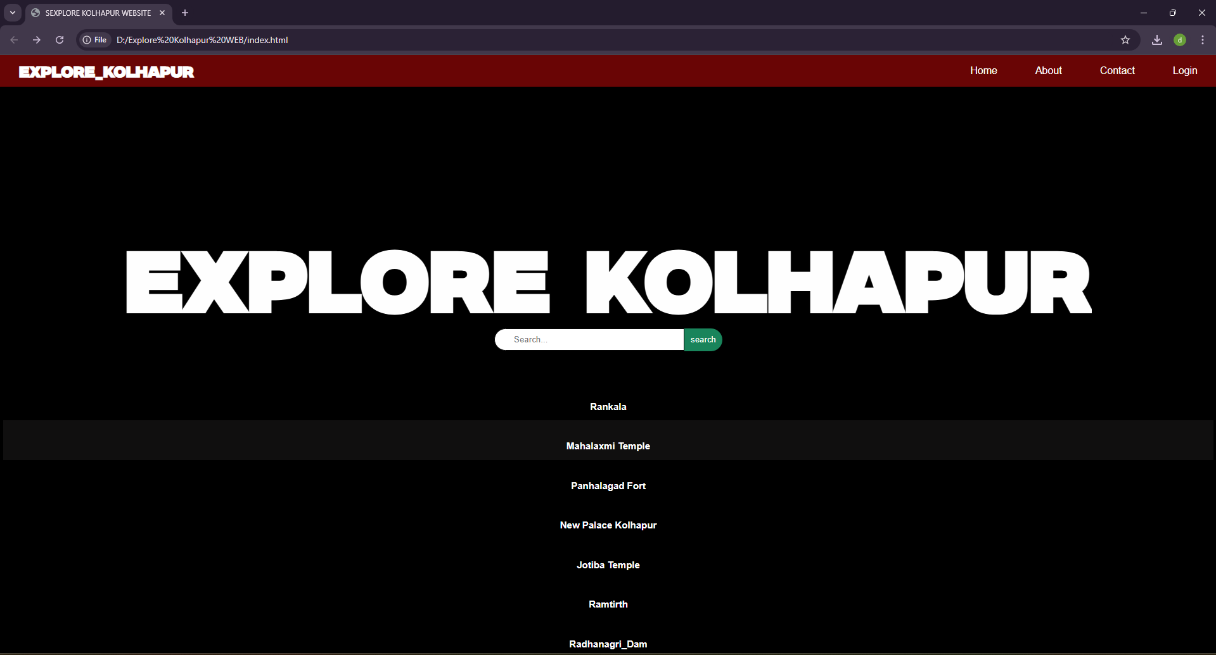

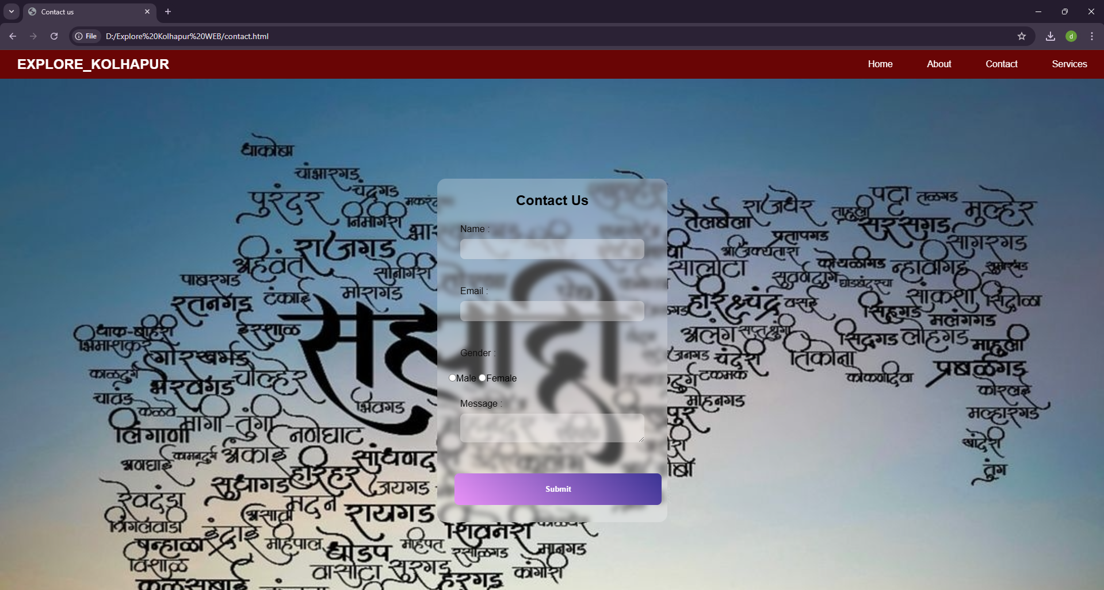

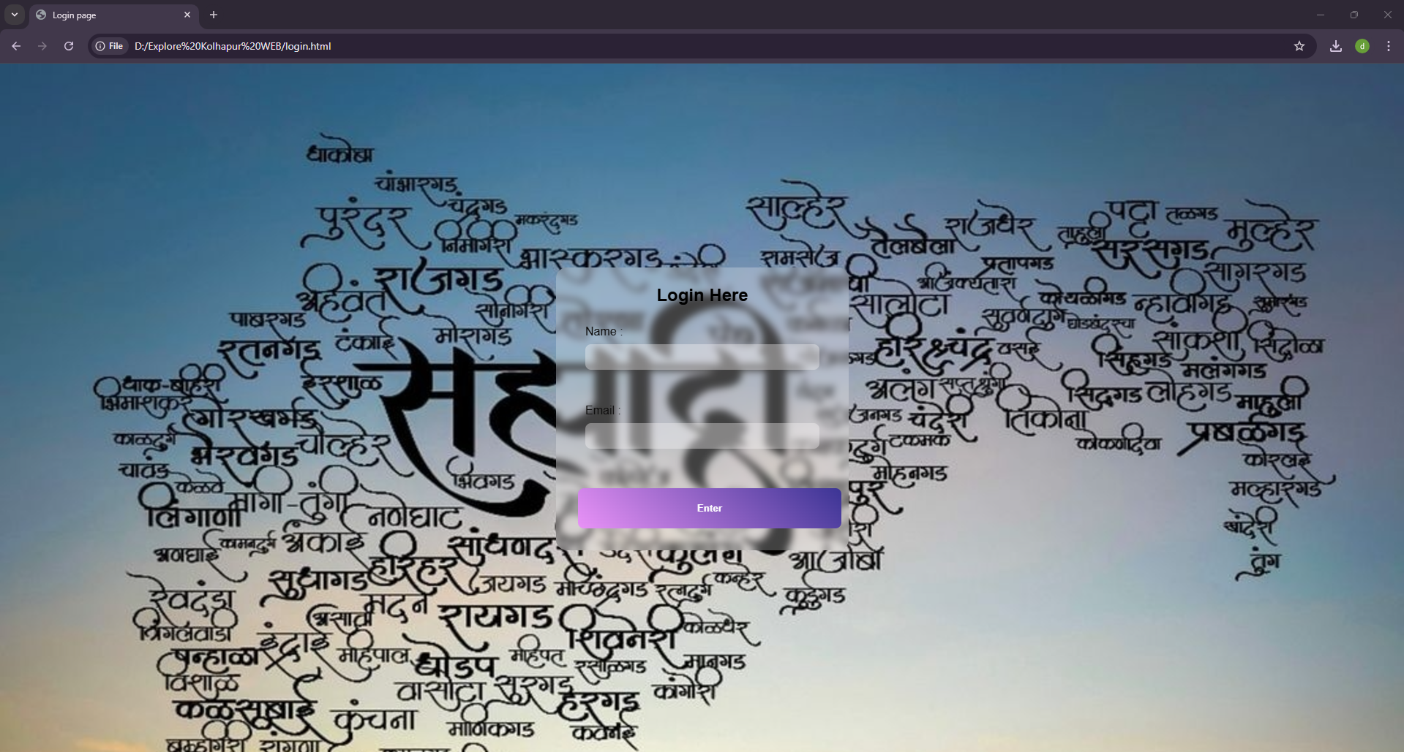

Conclusion
1)Explore Kolhapur is a comprehensive solution for travellers seeking reliable information and guidance for exploring destinations in Kolhapur. By offering personalized recommendations, detailed information about accommodations, amenities, and transportation, and a user-friendly interface, we empower travellers to plan their trips with confidence and ease. Our commitment to providing accurate and accessible information ensures that travellers can embark on unforgettable adventures throughout Maharashtra.
2) Kolhapur is an under-explored gem in Maharashtra's tourism landscape, with significant potential in religious, cultural, and eco-tourism. While the city is rich in history, culture, and natural beauty, there remain challenges related to infrastructure, marketing, and sustainable tourism practices. However, recent studies and developments indicate a growing awareness of these issues, and future tourism strategies focusing on digital marketing, community involvement, and sustainable practices could help Kolhapur emerge as a prominent tourist destination in the region.

